Contents

Summary 2

ER Diagram 3

Relational Model 4

Database Architecture 7

Final Set of Tables 9

Specification of constraints 17

Specification of Indexes 19

Specification of Stored Procedures 20

Specification of Triggers 21

Specification of Views & Joins 22

Specification of Built in Functions 24

Specification of User Defined Functions 25

Security Plan 26

Appendix Database Creation 28

Appendix Table creation 30

Appendix Stored Procedures 35

Appendix Triggers 38

Appendix Views 40

Appendix User Defined Functions 42

Conclusion 43

Summary- Hotel Reservation System

- All rooms have numbers. Room can be a Suit, Cabana, Deluxe or Standard room, but all the rooms contain a Room Number. Some rooms contain a name, but it is not considered as the unique identification of that room. Unique identification for all the rooms will be the Room Number.

- All rooms must have a bathroom, and one room has only one bathroom.

- One guest can reserve more than one room in one reservation. But one room can be reserved only by one guest at one time.

- One guest can receive more than one invoice.

- Invoice contains the additional charges and the amount paid at the reservation.

- To indicate the room availability, there is a field called availability. When a customer reserves a room, Availability field will be updated as the room is unavailable.

- When a user wants to cancel a reservation, his reservation amount is not paid back and for the cancellation a Cancellation Number will be generated.

- A reservation can contain more than one room.

- One guest can receive more than one invoice according to the rooms he reserved.

- Every hotel has at least one room and every hotel has checked in at least one guest.

- One reservation can be divided into more than one invoice.

ER Diagram
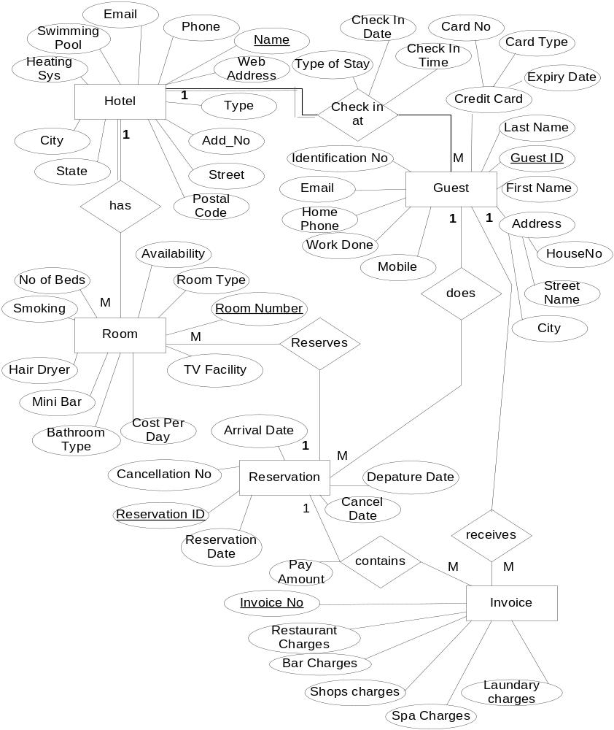
Relational Model

Hotel
{Name, Type, DoorNo, Street, City, State, PostalCode, WebAddress, Phone, Email, SwimmingPool, HeatingSystem }

Guest
{GuestID, IdentificationNo, FirstName, LastName, CreditCard, Address, Mobile, WorkDone, HomePhone, Email, TypeOfStay, CheckInDate, CheckInTime, Name}

Reservation
( ReservationID, ReservationDate, ArrivalDate, DepatureDate, CancellationNo, CancelDate , GuestID)

Room
{ RoomNumber, RoomType, NoOfBeds, CostPerDay, Smoking, HairDryer, TVFAcility, IAP, MiniBar, BathroomType, Availability, Name, ReservationID}

Invoice
{InvoiceNo, RestaurantCharges, BarCharges, ShopsCharges, SpaCharges, LaundaryCharges, PayAmount, ReservationID}

1NF Normalization

Hotel
{Name, Type, Add_No, Street, City, State, PostalCode, WebAddress, Phone, Email, SwimmingPool, HeatingSystem }

Guest
{GuestID, IdentificationNo, FirstName, LastName, CreditCardNo, ExpiryDate, CardType, HouseNo, StreetName, City, Mobile, WorkDone, HomePhone, Email, TypeOfStay, CheckInDate, CheckInTime , Name }

Reservation
( ReservationID, ReservationDate, ArrivalDate, DepatureDate, CancellationNo, CancelDate , GuestID )

Room
{ RoomNumber, RoomType, NoOfBeds, CostPerDay, Smoking, HairDryer, TVFacility, MiniBar, BathroomType, Availability , ReservationID }

Invoice
{InvoiceNo, RestaurantCharges, BarCharges, ShopsCharges, SpaCharges, LaundaryCharges, PayAmount , ReservationID }

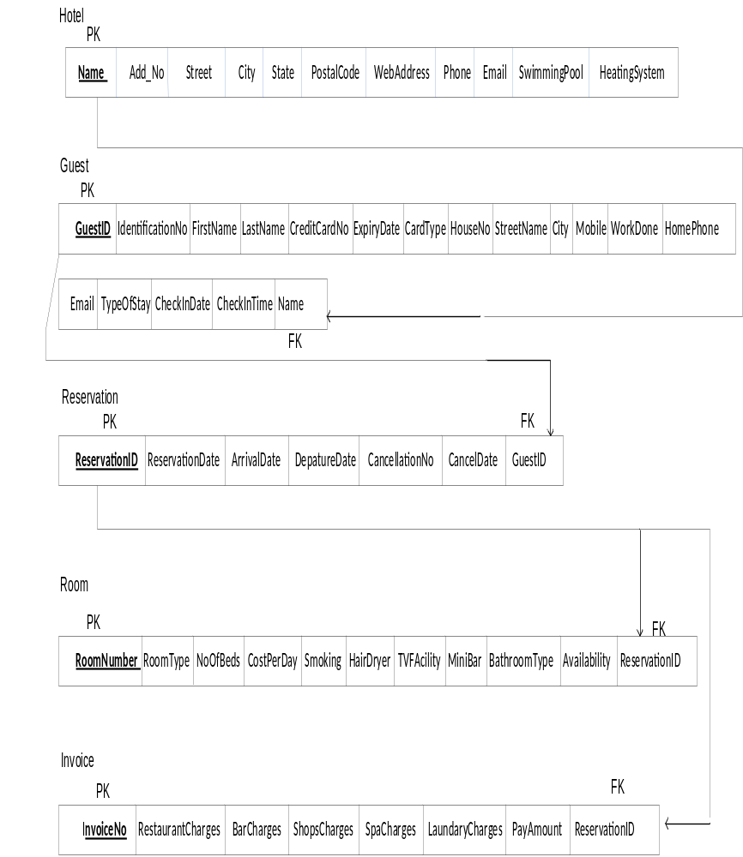

2NF Normalization

Any of the above relations does not have partial dependencies. No attributes can be identified by the part of the primary key. So all above relations are in 2NF.

3NF Normalization

There are no transitive dependencies in any relation. So, above relations are in the 3NF also.

Database Architecture

File Groups
In the dbSuperMarket database we have added the following file groups and files.
- primary file group
primary data file (Hotelresys.mdf)

- secondary file groups
  - FGFixedData
    - Secondary data files
      - Hotelresys 1.ndf
      - Hotelresys 2.ndf
  - FGVariableData
    - Secondary data files
      - Hotelresys 3.ndf
      - Hotelresys 4.ndf

